# Output Design

The output design of the counter will look similar to this:

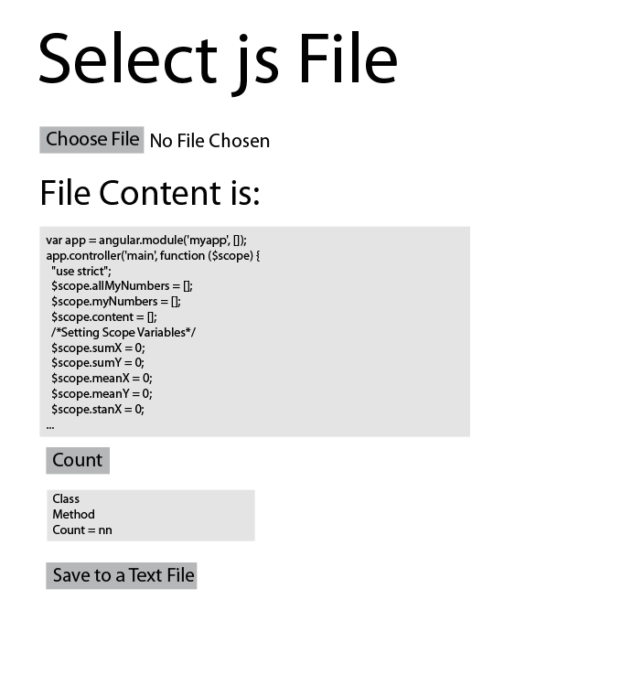

Clearly has a ‘choose file’ button that loads the JS file. The contents of the file are then displayed to the screen in a box. From there the ‘count’ button is pressed and the output of the count is given. The user then has the option to save the output to a text file.

The actual output design turned out similar to what I had planned as seen below:

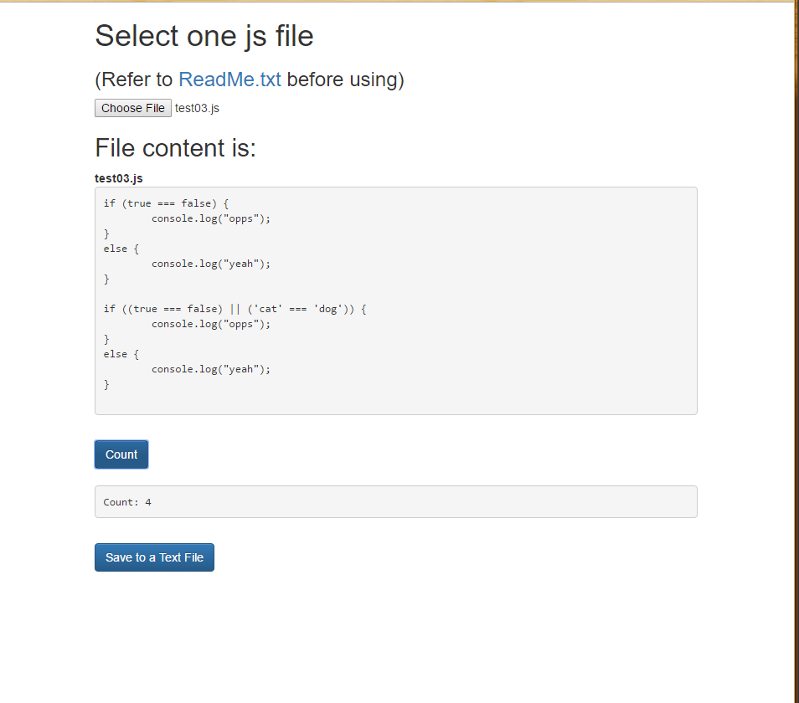

# Method Decomposition Plan

My plan for the Logical Line Counter program is to follow my counting standard of checking each line to see if there is a semi colon and if there is then that counts as a logical line. To do this I will need to create a regular expression and set up arrays to hold the values. Hopefully I can get it to read a directory and output the counts for each file. But if not it will at least work on one file at a time. The count will also be able to be saved to a text file.